**SOFTWARE REQUIREMENT ENGINEERING**

**Smart Appliances**

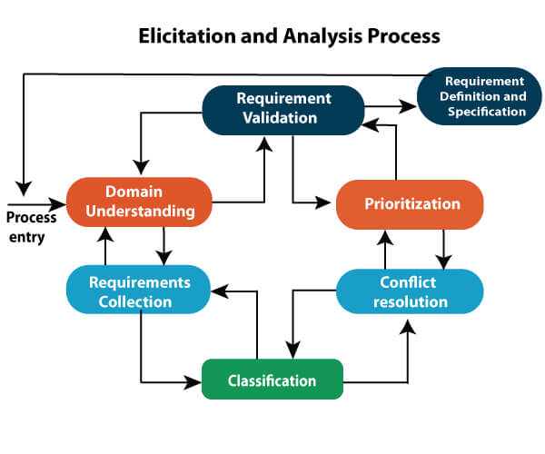

Contributed by: Abdullah Imran

**Note: This document will cover my work for the project. This is not an SRS document.**

**What is our project about?** **4**

**Requirement Elicitation** **4**

**Step 1: Pre-analysis of requirement elicitation** **4**

Step 1.1: Identifying the home users of the application 4

Step 1.2: Identifying the business users of the application 5

Step 1.3: Identifying the possible stakeholders 5

Step 1.4: Identifying the possible persons to be interviewed 5

**Step 2: Preparing the interview questionnaires and conducting the interviews:** **5**

2.1: Interview of the home users of our platform: 6

Interview 2: 8

2.3: Interview of the business users: 16

**2.4: Surveys of the users:** **21**

Surveys of the home users: 21

Surveys for business users: 21

**2.5: Requirement for company users** **21**

Who are the company users? 21

Registration process: 21

**2.6: Documentation Analysis** **24**

Home user: 24

Business users: 26

**Step 3: Requirement Analysis:** **27**

3.1: Extracting the user requirements: 27

3.1.1: User Requirements for home users: 27

3.1.2: User Requirements for business users: 28

3.1.3: User requirements for company users: 28

3.2: Defining user classes: 28

Favored user classes: 28

Disfavored user classes: 29

Ignored user classes: 29

Other user classes: 29

3.3: Define Use cases: 29

3.4: Writing use case descriptions: 30

1. Login/Logout 30

2. Create Room 33

3. Add appliances 35

4. Schedule appliances 38

5. View device analytics 40

6. Register your company’s devices 43

7. Schedule Policy Meeting 46

8. Make a Payment 48

9. Compile & Send device reports 50

10. Add other users 53

11. Manage system settings 57

12. Enable security mode 59

3.5: Use case Diagram: 62

Use Case Diagram 1: 62

Use Case Diagram 2: 64

**Step 4: Requirement Specification:** **65**

**Step 5: Requirement Validation:** **65**

5.1: Review the requirements: 66

5.2: Testing the requirements: 66

1. Test Case: Payment Processing 66

2. Test Case: Scheduling Appliances 67

3. Test Case: Room Creation 67

4. Test Case: Adding Appliance to a Room 68

5. Test Case: Email Notification 69

5.3: Defining acceptance criteria: 70

1. Functionality: 70

2. Performance: 70

3. Security: 71

4. Usability: 71

5.4: Simulate the requirements: 71

**Step 6: Prototyping:** **73**

Home user prototype: 73

Company user prototype: 74

System admin prototype: 74

# What is our project about?

We are building a platform that can automate the appliances such as A/C, fridges, vacuum cleaners, etc. These appliances can be controlled via our platform and managed. The appliances can also be scheduled to be turned on or off at a specific time. They can also be controlled remotely. Homes and businesses can use our platform to manage their appliances. Secondly, our platform also provides the facility for companies to register their products with our platform to be compatible with our application. In this way, our platform can be used to manage smart appliances by everyday users.

# Requirement Elicitation

Requirement Elicitation is a process of identifying the requirements of the customers, users, and other stakeholders from the platform which we are building. In our case, we are building a commercial product in the shape of a business startup which requires evaluating our product's potential users, interviewing them, asking them what they expect from our product, and designing our product based on their perspective and ease.

# Step 1: Pre-analysis of requirement elicitation

In our pre-analysis of the requirement elicitation, we would be analyzing the steps that are important to identify before starting the elicitation process itself.

## Step 1.1: Identifying the home users of the application

* Users who want to automate their homes
* Users who live far away from their homes and want to automate their homes remotely
* Users who want to keep track of their appliances and possible hazards they might cause

## Step 1.2: Identifying the business users of the application

* Businesses that want to automate their appliances within the premises of the organization
* Businesses who want to schedule their appliances to be turned on or off automatically as per the given time
* Businesses that want to keep track of how much of their appliances are being used

## Step 1.3: Identifying the possible stakeholders

* homeowners
* Businesses that want to manage their appliances
* Remote users of the platform
* Tech companies that develop smart appliances
* The builders of this application – us
* The investors of the application
* The competitors in the market

## Step 1.4: Identifying the possible persons to be interviewed

* Home users of the platform
* Business users of the platform
* Expert in the field
* Representatives of the manufacturing companies who want to register their products with us.

# Step 2: Preparing the interview questionnaires and conducting the interviews:

## 2.1: Interview of the home users of our platform:

**Interview 1:**

1. How often do you use appliances like air conditioners, fridges, or vacuum cleaners in your home?

The interviewee says that they use these appliances regularly.

2. Are you familiar with the concept of smart appliances that can be controlled through a platform or app?

The interviewee is familiar with this idea but hasn’t used it specifically for home appliances but has used this concept in the case of security cameras.

3. Have you used any automation or control systems for your appliances before?

The interviewee says that they haven’t used any platform for such a purpose but are planning to do that in the future, particularly the smart vacuum cleaners.

4. How would you benefit from being able to control your appliances through our platform? (Examples: convenience, energy savings, increased security)

The interviewee says that our platform would help them in saving their energy and will increase the security of their house.

5. What specific appliances would you like to control through our platform?

The interviewee says that they will be using smart vacuum cleaners and perhaps other appliances when they will get popularized in the market.

6. Are there any specific features or functionalities you would like to see in the platform?

The interviewee stresses the point that the application must be simple to use, but they aren’t clear about what features the application would have besides the already added ones.

7. Would you be interested in scheduling your appliances to turn on or off at specific times? If yes, can you provide some examples?

The interviewee says that they don’t have any plans to schedule their devices to be turned on or off for their convenience as their job concluding time is different based upon the work.

8. How important is it for you to be able to control your appliances remotely (e.g. when you're away from home)?

The interviewee says that it is important for them to be able to control their appliances remotely, especially when they are away from home. It will help them keep track of their appliances.

9. Do you have any concerns about the security or privacy aspects of using a platform to control your appliances?

The interviewee stresses the importance of privacy and security of the application and they think that lack of these points will grow the number of unauthorized users on the platform which can cause privacy concerns for their home.

10. Are there any other suggestions or feedback you would like to provide regarding our platform?

The interviewee does not have any further feedback regarding it.

**Interviewing details:**

Conductor of the interview: Abdullah Imran

Interview conducted on: 17/05/2023

Attachment(s): <https://drive.google.com/file/d/1Pad9e4Z3nCZA_Gq3KimEyuPFHojL6y0d/view?usp=share_link>

## Interview 2:

1. How often do you use appliances like air conditioners, fridges, or vacuum cleaners in your home?

The interviewee says that they use these appliances regularly.

2. Are you familiar with the concept of smart appliances that can be controlled through a platform or app?

The interviewee is familiar with this idea but hasn’t used it specifically for home appliances but has used this concept in the case of security cameras. They have given the example of an Alexa smart speaker and Apple’s Siri-based home automation applications.

3. Have you used any automation or control systems for your appliances before?

The interviewee says that they haven’t used any platform for such a purpose but they have used it for security cameras apps.

4. How would you benefit from being able to control your appliances through our platform? (Examples: convenience, energy savings, increased security)

The interviewee says that our platform would help them in saving their energy and will increase the security of their house.

5. What specific appliances would you like to control through our platform?

The interviewee says that they will be using a smart TV, smart fridge, and smart microwave ovens through our platform. They say that they will use it when the electricity is dim so that they can use our platform to turn these appliances off.

6. Are there any specific features or functionalities you would like to see in the platform?

The interviewee says that they like to use our platform to adjust the settings of the appliances as well such as adjusting the temperature of the A/C and adjusting the brightness of the lights.

7. Would you be interested in scheduling your appliances to turn on or off at specific times? If yes, can you provide some examples?

The interviewee says that they do plan to use this feature as when they are away from their home, they can schedule their home’s outside lights to be turned on at night and turned off during the day.

8. How important is it for you to be able to control your appliances remotely (e.g. when you're away from home)?

The interviewee repeats the previous example they have given, which is that if they are away from home, they can control their appliances and turn them off in case the electricity is dim.

9. Do you have any concerns about the security or privacy aspects of using a platform to control your appliances?

The interviewee stresses the importance of privacy and security of the application and they think that lack of these points will grow the number of unauthorized users on the platform which can cause privacy concerns for their home.

10. Are there any other suggestions or feedback you would like to provide regarding our platform?

The interviewee says that the platform must be convenient/ easy to use and must have good security. They also suggest that our platform should be able to provide passwords to other persons so that they can also use the appliances in the home.

**Interviewing details:**

Conductor of the interview: Abdullah Imran

Interview conducted on: 18/05/2023

Attachment(s): <https://drive.google.com/file/d/1PLtZCzGi0e4Urt8B6p5gLN2OIZtVq9lZ/view?usp=share_link>

**Interview 3:**

1. How often do you use appliances like air conditioners, fridges, or vacuum cleaners in your home?

The interviewee says that they use these appliances regularly and it is their daily need.

2. Are you familiar with the concept of smart appliances that can be controlled through a platform or app?

The interviewee is familiar with this idea but hasn’t used it specifically for their home appliances.

3. Have you used any automation or control systems for your appliances before?

The interviewee says that they haven’t used any platform for such a purpose but they have used it for security cameras apps.

4. How would you benefit from being able to control your appliances through our platform? (Examples: convenience, energy savings, increased security)

The interviewee says that our platform would help them in saving their energy and will increase the security of their house.

5. What specific appliances would you like to control through our platform?

The interviewee says that they will be using a smart TV, smart fridge, and smart microwave ovens through our platform. They say that they will use it when the electricity is dim so that they can use our platform to turn these appliances off.

6. Are there any specific features or functionalities you would like to see in the platform?

The interviewee says that they like to use our platform to adjust the settings of the appliances as well such as adjusting the temperature of the A/C and adjusting the brightness of the lights.

7. Would you be interested in scheduling your appliances to turn on or off at specific times? If yes, can you provide some examples?

The interviewee says that they do plan to use this feature as when they are away from their home, they can schedule their home’s outside lights to be turned on at night and turned off during the day.

8. How important is it for you to be able to control your appliances remotely (e.g. when you're away from home)?

The interviewee repeats the previous example they have given, which is that if they are away from home, they can control their appliances and turn them off in case the electricity is dim.

9. Do you have any concerns about the security or privacy aspects of using a platform to control your appliances?

The interviewee stresses the importance of privacy and security of the application and they think that lack of these points will grow the number of unauthorized users on the platform which can cause privacy concerns for their home.

10. Are there any other suggestions or feedback you would like to provide regarding our platform?

The interviewee says that the platform must be convenient/ easy to use and must have good security. They also suggest that our platform should be able to provide passwords to other persons so that they can also use the appliances in the home.

Conductor of the interview: Ahmed Khan

Interview conducted on: 19/05/2023

Attachment(s): <https://drive.google.com/file/d/1SS_Gc2JguEm-zBnEvcOtXr3fNPPTuu-e/view?usp=sharing>

**Interview 4:**

1. How often do you use appliances like air conditioners, fridges, or vacuum cleaners in your home?

The interviewee says that they use these appliances regularly and it is their daily need. The frequency of the usage of these appliances depends on the need.

2. Are you familiar with the concept of smart appliances that can be controlled through a platform or app?

The interviewee is familiar with this idea but hasn’t used it specifically for their home appliances.

3. Have you used any automation or control systems for your appliances before?

The interviewee says that they haven’t used any platform for such a purpose but they are open to testing and use this whenever they get the opportunity in the future.

4. How would you benefit from being able to control your appliances through our platform? (Examples: convenience, energy savings, increased security)

The interviewee says that our platform would help them in saving their energy and will increase the security of their house.

5. What specific appliances would you like to control through our platform?

The interviewee says that they will be using several devices such as A/C, oven, vacuum cleaner, and so on.

6. Are there any specific features or functionalities you would like to see in the platform?

The interviewee seems to have targeted the generic functionalities and features.

7. Would you be interested in scheduling your appliances to turn on or off at specific times? If yes, can you provide some examples?

The interviewee does plan to use this feature especially when they are away from their home for some work.

8. How important is it for you to be able to control your appliances remotely (e.g. when you're away from home)?

The interviewee seems to be using this feature when they are away from home.

9. Do you have any concerns about the security or privacy aspects of using a platform to control your appliances?

The interviewee stresses the importance of privacy and security of the application and they think that lack of these points will grow the number of unauthorized users on the platform which can cause privacy concerns for their home.

10. Are there any other suggestions or feedback you would like to provide regarding our platform?

The interviewee hasn’t shared any feedback.

Conductor of the interview: Muhammad Aqeel

Interview conducted on: 19/05/2023

Attachment(s): <https://drive.google.com/file/d/1SZFcX92ZBc9OhhIpX-XolMyxgcCddMK0/view?usp=share_link>

**Interview 5:**

1. How often do you use appliances like air conditioners, fridges, or vacuum cleaners in your home?

The interviewee says that they use these appliances regularly and it is their daily need. The appliances they used mostly are A/Cs, fridges, etc.

2. Are you familiar with the concept of smart appliances that can be controlled through a platform or app?

The interviewee is familiar with this idea and has used this in the form of security cameras.

3. Have you used any automation or control systems for your appliances before?

The interviewee says that they are currently using this with their fans and the security cameras but they would like to modify it with better tech in the future.

4. How would you benefit from being able to control your appliances through our platform? (Examples: convenience, energy savings, increased security)

The interviewee says that our platform will make their lives more convenient and relevant to controlling their home appliances.

5. What specific appliances would you like to control through our platform?

The interviewee says that they will be using several devices such as A/C, oven, vacuum cleaner, and so on.

6. Are there any specific features or functionalities you would like to see in the platform?

The interviewee has said that they will be utilizing the current features of the application to control their appliances, nothing more.

7. Would you be interested in scheduling your appliances to turn on or off at specific times? If yes, can you provide some examples?

The interviewee does plan to use this feature such as when they use their home appliances and they have to leave for some work.

8. How important is it for you to be able to control your appliances remotely (e.g. when you're away from home)?

The interviewee said that they will be using this feature to prevent any mishaps and conserve energy.

9. Do you have any concerns about the security or privacy aspects of using a platform to control your appliances?

The interviewee stresses the importance of privacy and security of the application and they think that lack of these points will grow the number of unauthorized users on the platform which can cause privacy concerns for their home.

10. Are there any other suggestions or feedback you would like to provide regarding our platform?

The interviewee has advised to make this system more familiar to the general public. They have also said that the interface of the application must be user-friendly.

Conductor of the interview: Muzammal Maqsood

Interview conducted on: 21/05/2023

Attachment(s): <https://drive.google.com/file/d/1T7UZrJVOB52eJnuCcBzSIScXMJLUWwxT/view?usp=sharing>

## 2.3: Interview of the business users:

**Interview 1:**

1. In what type of business or industry do you operate?

The interviewee has said that their business operates in the hospitality sector specifically in the hotel industry.

2. Do you currently use any automation or control systems for managing appliances in your business?

The interviewee has said that they currently do not use any automation controls in their businesses.

3. How would your business benefit from being able to control and manage appliances through our platform? (Examples: cost savings, improved operational efficiency, better resource management)

The interviewee has said that they will be able to achieve cost savings in their businesses and energy efficiency by scheduling the appliances to be turned on or off at a specific time.

4. Which specific appliances in your business would you like to control through our platform?

The interviewee has said that they would like to control their A/Cs, lighting, and TVs via our platform.

5. Are there any specific features or functionalities you would like to see in the platform that would benefit your business operations?

The interviewee said that they would like to see which appliances are being used in what particular use and their consumption rates.

6. Would you be interested in scheduling your appliances to turn on or off at specific times? If yes, can you provide some examples?

The interviewee has previously mentioned that they will like to schedule their appliances to be turned on or off at specific times such as when a person checks out, etc.

7. How important is it for you to be able to control your appliances remotely (e.g. when you're not on-site)?

What we can assume from the hospitality industry is that mostly they are on-site and they don’t need to control their appliances remotely. However, they will still like this feature in case of emergency.

8. Do you have any concerns about the security or privacy aspects of using a platform to control your appliances in a business setting?

The interviewee operates in the hospitality industry and would like to see some of the security methods adopted.

9. Are there any other suggestions or feedback you would like to provide regarding our platform and its compatibility with your business's appliances?

The interviewee has not given any feedback.

**Interviewing details:**

Conductor of the interview: Muhammad Aqeel

Interview conducted on: 20/05/2023

Attachment(s): <https://drive.google.com/file/d/1SX05pF2L6Jd0AqSBzxoEBW0_Ov77yRs-/view?usp=sharing>

**Interview 2:**

1. In what type of business or industry do you operate?

The interviewee has said that they do a business of water filtration and their industry is related to that.

2. Do you currently use any automation or control systems for managing appliances in your business?

The interviewee has said that they haven’t used any automation or control systems for managing their business but they plan to do that in the near future.

The interviewee has said that they currently do not use any automation controls in their businesses.

3. How would your business benefit from being able to control and manage appliances through our platform? (Examples: cost savings, improved operational efficiency, better resource management)

It is assumed that they will be able to achieve cost savings in their businesses and energy efficiency by scheduling the appliances to be turned on or off at a specific time. They have mentioned they would like to turn their motors off which can be done via a smart wall outlet.

4. Which specific appliances in your business would you like to control through our platform?

The interviewee has said that they would like to control their motors via our platform so that they can turn them on or off at specific times.

5. Are there any specific features or functionalities you would like to see in the platform that would benefit your business operations?

The interviewee said that they will like the application to be user-friendly.

6. Would you be interested in scheduling your appliances to turn on or off at specific times? If yes, can you provide some examples?

The interviewee has said they would like to control their motors to be scheduled to be turned on or off at specific times such as when they are outside.

7. How important is it for you to be able to control your appliances remotely (e.g. when you're not on-site)?

For the interviewee when they are not on-site, they need to be able to control their motors to prevent any mishap.

8. Do you have any concerns about the security or privacy aspects of using a platform to control your appliances in a business setting?

It is assumed that the security and privacy concern doesn’t matter in this specific business.

9. Are there any other suggestions or feedback you would like to provide regarding our platform and its compatibility with your business's appliances?

The interviewee has said that their motors must not be disconnected unless they have not turned it off themselves as it can create a possible mishap and can give loss to their business.

**Interviewing details:**

Conductor of the interview: Ahmed Khan

Interview conducted on: 20/05/2022

Attachment(s): <https://drive.google.com/file/d/1SxrA9Uv8wimqwF_H3TF6nKpttLIXH11q/view?usp=sharing>

**Interview 3:**

Conductor of the interview:

Interview conducted on:

Name of the interviewee:

Attachment(s):

# 2.4: Surveys of the users:

## Surveys of the home users:

<https://docs.google.com/forms/d/10pQYTOc491CZqwChovLAwaMK8qqqRBDZm68vyLdqDCc/edit>

## Surveys for business users:

https://docs.google.com/forms/d/1LDwdmgOJD2a6o0TCfd4a5ib0LLvYfipk9WKBg6B2WTM/edit

# 2.5: Requirement for company users

## Who are the company users?

Company users are those companies who wish to register their smart appliances on our platform so that our home and business users can use their devices on our platform. So, company users will also be our primary users. These companies will be able to register their products on our platform via a separate section called "Register your company's devices".

## Registration process:

Here is what we plan for the registration process:

Step 1: The company that wishes to register its smart appliances will visit our platform.

Step 2: They will need to sign up/log in to proceed further.

Step 3: They will go under the section "Register your company’s devices".

Step 4: They will enter the name of their company, the address, etc.

Step 5: They will enter the significant names of the devices that they wish to register, such as "Smart Lights," "Smart Fridge," "Smart A/C," etc. Additionally, a new button will be displayed after selecting a major device, such as "Smart Light". Clicking on the button will prompt the user to enter the following details for each device:

- Brand of the company (required)

- Model of the product (required)

- Technical specifications of the product, such as compatibility and energy consumption (required)

- Integration requirements (required)

Users can also add more devices under the same section by clicking on the "Add new device" button. Additionally, users will be asked to provide their email, phone number, and other credentials. They will also be given the option to choose between on-site or Zoom meetings for further discussions.

Step 6: A meeting will be scheduled between the representatives of the company users and our representatives. During this meeting, a plan will be devised regarding profit margins, revenue sharing, and other business-related aspects. The meeting will also address the specific data points that the company wants to track for their registered devices, the frequency of receiving reports, and the desired report format. Technical support needs will also be discussed.

Step 7: Our team will manually ensure compatibility between the registered devices of the company and our platform. Once the process is completed, these devices will be displayed to our business and home users on our application.

Step 8: Updates and feedback will be shared with the company users in monthly reports, which will be gathered via our platform. The reports will include information such as the devices being used, customer feedback, interest in each device, and daily usage statistics. If the company users have additional requests, we will accommodate them accordingly. The reports will be emailed to the registered email address of the company user.

**Gathering company user requirements:**

Since we do not have direct access to smart appliance manufacturing companies, we will take examples from companies like Samsung and Microsoft on how they handle the registration process for their customers. We will incorporate their best practices into our registration process. For example, the login section, authorization section, and company details can be similar to the process used by Samsung and Smart Connect. We will also adopt their approach of allowing users to select major device sections from a drop-down menu and dispatching the request. Following that, an email will be sent to the user to select possible meeting dates and time slots to arrange further discussions.

**Sources:**

Samsung: <https://www.samsung.com/ca/support/apps-services/how-to-register-home-appliances-in-the-smartthings-app/>

[Home Connect: https://www.home-connect.co.nz/help-support/pairing-finder](https://www.home-connect.co.nz/help-support/pairing-finder)

# 2.6: Documentation Analysis

## Home user:

**Source 1:**

<https://smartliving.hkt.com/pdf/Smart_Living_Home_Automation_Solution_Samsung_Connect_App_User_Guide_v201907-eng.pdf>

* All connected devices are displayed and the user can control or check the status of each device. Frequently-used devices can be displayed on the main page for easy control.
* The user can invite others to connect their devices to a household’s SmartThings Wifi. The user can send invitations to Samsung accounts or scan QR codes. Invitees need to register for a Samsung account to log into the app.
* The app lets you create multiple rooms and control their devices via those particular rooms.
* The app lets you see the current usage of the smart device and how much energy it is using, etc.

**Source 2:**

<http://www.chnsmart.com/download/app_user_guide.pdf>

* Requirements for OS needed to be set up such as Android 6 and onwards, etc.
* A username and password are required for login each time. Passwords are required to be entered each time you log in.
* Set the names of each room. Once you add a new room, you can connect the devices of that room so that the devices of other rooms can’t be confused with that room.
* You can turn them on or off, or click them further to go into more details such as their usage, etc.
* Add a timer or schedule your device to be turned on at a specific time or turn it off.

**Rise of the home appliances, a success story:**

Source: [A look into the future of smart home devices (gfk.com)](https://www.gfk.com/blog/a-look-into-the-future-of-smart-home-devices)

The pandemic gave a significant boost to consumer appetite for smart home devices. The future of smart home devices depends on brands and marketers showing consumers what a connected, smart home looks like, clearly communicating its benefits, and how easily the products connect and work together.

People come to smart home devices with one problem at a time and create a smart home by accident or accretion, rather than by decision. The future of smart home devices, particularly smart home automation products, relies on brands finding ways to overcome barriers such as security and privacy concerns, complexity, and the cost of entry. Connected devices will in theory work on other platforms such as Google, so a lot of it is about communication to reassure consumers. More and more devices are coming online that support integration with the big technology firms' infrastructure. The most common way to increase consumer adoption of smart home devices is still by encouraging people to have multiple devices from the same manufacturer.

* As the technology continues to evolve, we can expect to see even more innovative and user-friendly smart home devices on the market.
* Smart home devices have the potential to make our lives easier and more convenient in many ways. For example, they can help us to save energy, automate tasks, and stay connected with our loved ones.
* However, it is important to note that smart home devices also come with some potential risks, such as security and privacy concerns. It is important to do your research and choose secure smart home devices that respect your privacy.
* Overall, the future of smart home devices looks bright. With continued innovation and adoption, smart home devices have the potential to make our lives better in many ways.

## Business users:

**Source 1:** [A value-based view of the smart PSS adoption: a study of smart kitchen appliances | SpringerLink](https://link.springer.com/article/10.1007/s11628-023-00529-9)

Samsung has partnered with Whisk, a smart food platform that provides personalized recipe recommendations based on user preferences, dietary needs, and inventory. Samsung integrated Whisk into its Family Hub smart refrigerator, which allows users to plan meals, create shopping lists, and order groceries directly from the fridge screen. Samsung claims that this smart appliance can help users save time, money, and food waste1. According to a case study by Whisk, Samsung saw a 30% increase in user engagement and a 50% increase in repeat usage after integrating Whisk into its smart refrigerator.

**Source 2:** [Mapping the Smart-Home Market (bcg.com)](https://www.bcg.com/publications/2018/mapping-smart-home-market)

LG has collaborated with Drop, a smart kitchen platform that connects various smart appliances and provides guided cooking experiences. LG integrated Drop into its ThinQ smart oven, which can automatically adjust the temperature and cooking time based on the recipe selected by the user. LG says that this smart appliance can help users cook more easily, efficiently, and deliciously. According to a case study by Drop, LG saw a 40% increase in app downloads and a 25% increase in app ratings after integrating Drop into its smart oven.

**Source 3:** [The Top 10 IoT Use Cases (iot-analytics.com)](https://iot-analytics.com/top-10-iot-use-cases/)

Bosch has developed a smart home system called Home Connect, which connects various smart appliances such as washing machines, dryers, dishwashers, coffee machines, and security cameras. Bosch says that Home Connect can help users control and monitor their smart appliances remotely via an app or voice assistant, as well as provide tips and support for optimal performance. According to a case study by Bosch, Home Connect has helped users save up to 30% of energy and water consumption, as well as reducing maintenance costs and increasing customer satisfaction.

# Step 3: Requirement Analysis:

## 3.1: Extracting the user requirements:

### 3.1.1: User Requirements for home users:

* User Account Management: the ability to create an account and update its info.
* Subscription and payment: The user will be able to know the subscription fee and will be provided with a secure method of payment.
* Smart Appliance Control: A user-friendly interface will let the users control their appliances via **Smart Appliances, which** will provide them with the usage details of those appliances.
* Room and Device Management: The ability to create multiple rooms in your house and then add the smart appliances that you want to control with it by scanning the QR code at its back.
* Remote Access to the smart appliances
* Scheduling of the smart appliances

### 3.1.2: User Requirements for business users:

* User Account Management: the ability to create an account and update its info.
* Subscription and payment: The user will be able to know the subscription fee and will be provided with a secure method of payment.
* Smart Appliance Control: A user-friendly interface will let the users control their appliances via **Smart Appliances, which** will provide them with the usage details of those appliances.
* Room and Device Management: The ability to create multiple rooms in your house and then add the smart appliances that you want to control with it by scanning the QR code at its back.
* Remote Access to smart appliances
* Scheduling of the smart appliances

### 3.1.3: User requirements for company users:

* Appliance compatibility and integration: We will ensure that the registered devices are compatible with our platform.
* Meeting scheduling with the representatives of the company users.
* Sales and Profit Management.
* Easy to use UI and easy process for registering the devices.
* Sending reports of the usage of their appliances to them after a specific period.

## 3.2: Defining user classes:

### Favored user classes:

* Home users
* Business users
* Company users
* The main stakeholder
* Banks

### Disfavored user classes:

* Hackers and security breaches
* Competitors organizations

### Ignored user classes:

* Application visitors
* Non paying users
* Users that are not aware of the technology

### Other user classes:

* System Admin
* Customer support
* Data analysts of the company users

## 3.3: Define Use cases:

1. Login/logout
2. Create Room
3. Add appliances
4. Schedule appliances
5. View device analytics
6. Register your company’s devices
7. Schedule a policy meeting
8. Make a payment
9. Send device report
10. Add other users
11. Manage system settings
12. Enable security mode

## 3.4: Writing use case descriptions:

### Login/Logout

| ID and Name: | UC-01, Login/logout |
| --- | --- |
| Created By: | Muhammad Aqeel |
| Created Date: | 28/05/2023 |
| Primary Actors: | Home users, Business users, Company users |
| Secondary Actors: | None |
| Description: | This use case allows Business Users, Home Users, and Company Users to log in to the platform using their credentials. If a user does not have an account, they will be directed to the sign-up process. The login functionality provides access to personalized features and settings within the platform. |
| Trigger: | The user initiates the use case by accessing the platform's login page. |
| Preconditions: | * The user must have an active account registered on the platform. * The user must have a valid email address and password. |
| Postconditions: | * The user is successfully logged into the platform and gains access to their personalized features. * For new users, if sign-up is successful, they receive a confirmation email. |
| Normal Flows: | 1. The user accesses the platform's login page. 2. If the user already has an account:   a. The user enters their email and password.  b. The user clicks the "Login" button.  c. The system validates the entered credentials.  d. If the credentials are valid, the user is successfully logged into the platform and is redirected to their personalized dashboard.  e. If the credentials are invalid, the system displays an error message indicating that the login attempt was unsuccessful.   1. If the user does not have an account:   a. The user clicks on the "Sign Up" or "Create Account" option.  b. The user is directed to the sign-up page.  c. The user enters their full name, email, contact number, and password.  d. The user clicks the "Sign Up" or "Create Account" button.  e. The system validates the entered information.  f. If the information is valid, the user's account is created, and they receive a confirmation email.  g. The user is then redirected to the login page.  h. The user enters their newly created email and password.  i. The user clicks the "Login" button.  j. The system validates the entered credentials.  k. If the credentials are valid, the user is successfully logged into the platform and is redirected to their personalized dashboard. |
| Alternative Flows: | 2 (alternate): If the user forgets their password:  The user clicks on the "Forgot Password" option.  The user is prompted to enter their email address.  The system sends a password reset link to the user's email.  The user follows the link and sets a new password. |
| Exceptions: | * If the user enters an incorrect email or password during the login process, the system displays an error message and prompts the user to re-enter the correct credentials. * If the user enters invalid or incomplete information during the sign-up process, the system displays an error message and prompts the user to provide valid and complete information. |
| Priority: | High |
| Frequency of Use: | This use case is used frequently by Business Users, Home Users, and Company Users every time they access the platform. |
| Business rules: | * Only registered users with valid credentials can log in to the platform. * Sign-up is required for new users who do not have an existing account. * User passwords should follow the platform's password policy (e.g.and , minimum length, complexity requirements). * Confirmation emails are sent to newly registered users for account verification. * The login/logout functionality must be secure and protect user privacy. |
| Other information: | * The confirmation email sent to new users may contain instructions on how to verify their email address or activate their account. |
| Assumptions: | * The platform's login page and sign-up page are accessible and properly designed. * The system has appropriate security measures in place to protect user credentials and personal information. * The user's email address serves as their unique identifier for logging in and receiving account-related notifications. * The password reset functionality is implemented securely and follows best practices. |

### Create Room

| ID and Name: | UC-02, Create room |
| --- | --- |
| Created By: | Muzammal Maqsood |
| Created Date: | 28/05/2023 |
| Primary Actors: | Home users, Business users |
| Secondary Actors: | None |
| Description: | This use case enables home and business users to create rooms within the smart home system. Users can organize their devices by assigning them to specific rooms. Each room is independent, and devices added to one room cannot be accessed from other rooms. Users can create multiple rooms and later add devices to them. The created rooms provide a structured view of devices within the platform. |
| Trigger: | The user initiates the use case by accessing the "Create Room" feature within the smart home system. |
| Preconditions: | 1. Users must be logged in to the smart home system. 2. Users must have permission to add the rooms. |
| Postconditions: | 1. The room is successfully created in the smart home system, ready for device association and management. 2. The room is visible to the user on the platform. 3. The user can proceed to add devices in that room. |
| Normal Flows: | 1. The User navigates to the room creation section within the smart appliance platform. 2. The User selects the option to create a new room. 3. The system displays a window for the User to enter the room details, such as the room name and optional description. 4. The User provides the required information, including the room name, and fills in any optional details. 5. The User “saves” the window to create the room. 6. The system validates the information provided and creates a new room associated with the User's account. 7. The system updates the user interface to reflect the newly created room. 8. The User can proceed to add devices to the created room or create additional rooms if desired. |
| Alternative Flows: | 4 (alternate): If the User enters a duplicate room name:   1. The system displays an error message indicating that a room with the same name already exists. 2. The User is prompted to enter a different room name or modify the existing room name. |
| Exceptions: | If there is a technical issue with creating a room, such as database errors or system unavailability, the system displays an error message and advises the User to try again later. |
| Priority: | Medium |
| Frequency of Use: | * Users can create rooms as needed to organize their devices within the smart appliance platform. * The frequency of room creation may vary depending on the User's preferences and needs but it is expected that most users will use this use case during the initial use of the platform. |
| Business rules: | 1. Each room is independent and can only contain devices assigned to it. 2. Devices added to one room cannot be accessed from other rooms. 3. Room names should be unique within the User's account. |
| Other information: | 1. Users can modify room details or delete rooms if necessary. 2. The created rooms provide a structured view of devices within the platform, enhancing organization and ease of use. |
| Assumptions: | 1. The user has basic knowledge of navigating and using the smart home system's interface. 2. The platform can handle a sufficient amount of created rooms per user account. |

### Add appliances

| ID and Name: | UC-03, Add appliances |
| --- | --- |
| Created By: | Muzammal Maqsood |
| Created Date: | 28/05/2023 |
| Primary Actors: | Home users, Business users |
| Secondary Actors: | None |
| Description: | This use case allows Home Users and Business Users to add devices or appliances to the rooms they have created within the smart appliance platform. Devices can be added to rooms either by scanning a QR code provided on the device or through a manual process that requires entering device details such as name, a unique number associated with that device, and company information. Devices added to a specific room can only be accessed and controlled within that particular room. |
| Trigger: | The user initiates the use case by accessing the "Add Appliances" feature within the created room. |
| Preconditions: | 1. The User must be registered and logged into the smart appliance platform. 2. The User must have created at least one room. 3. The User must have an internet connection. 4. The device to be added must be compatible with the smart appliance platform. |
| Postconditions: | 1. The selected device is added to the specified room within the User's account. 2. The device is associated with the room and can be controlled within that room only. |
| Normal Flows: | 1. The User navigates to the room management section within the smart appliance platform. 2. The User selects the desired room where the device will be added. 3. The system displays options to add a device to the selected room. 4. The User selects the desired method to add the device: QR code scanning or manual entry.   5a: QR Code Scanning:  i. The User selects the option to add the device by scanning a QR code.  ii. The User uses the camera of their device (e.g., smartphone) to scan the QR code on the back of the device.  iii. The system retrieves the device information from the scanned QR code and validates its compatibility with the platform.  iv. The User confirms the addition of the device to the selected room.  v. The system associates the device with the room and updates the User interface to reflect the addition.  5b. Manual Entry:  i. The User selects the option to add the device through manual entry.  ii. The User provides the required details, such as the device name, the unique number associated with the device, and company information, in the provided fields.  iii. The system validates the entered information and checks the compatibility of the device with the platform.  iv. The User confirms the addition of the device to the selected room.  v. The system associates the device with the room and updates the User interface to reflect the addition. |
| Alternative Flows: | 4(alternate). If the scanned QR code is invalid or not recognized:   * The system displays an error message indicating that the QR code is invalid or incompatible with the platform. * The User may retry scanning the QR code or choose the manual entry option. * If the appliance is not compatible with the application, the platform will display an error message that the device is not compatible with the platform. |
| Exceptions: | If there is a technical issue with adding a device, such as network connectivity problems or system unavailability, the system displays an error message and advises the User to try again later. |
| Priority: | Medium |
| Frequency of use: | * Users can add devices to rooms as needed, depending on their device acquisitions and room management preferences. * The frequency of adding devices to rooms may vary for each User but most likely this will be used during the initial setup of the platform by the user. |
| Business rules: | 1. Devices can only be added to rooms created within the User's account. 2. Devices added to a specific room can only be accessed and controlled within that room. 3. The platform must support device compatibility and validation during the addition process. |
| Other information: | 1. Once added, the user can further customize and configure the settings of each appliance within the smart home system. 2. The user can also remove or disconnect appliances from the system if needed. |
| Assumptions: | 1. The user has basic knowledge of connecting and setting up appliances. 2. The platform supports the addition of a variety of compatible devices. 3. The device information, whether obtained through QR code scanning or manual entry, is accurate and valid. |

### Schedule appliances

| ID and Name: | UC-04, Schedule devices |
| --- | --- |
| Created By: | Abdullah Imran |
| Created Date: | 25/05/2023 |
| Primary Actors: | Home users, Business users |
| Secondary Actors: | None |
| Description: | This use case allows the homes and business users to schedule their appliances within the system. The users can enter specific time intervals for turning the appliances on or off at that specific time, providing convenience and energy savings for the users. |
| Trigger: | The user initiates the case by clicking on the particular device and then further clicking on the option “Schedule appliance”. |
| Preconditions: | 1. Users must be logged in. 2. The appliances to be scheduled must be connected to the platform. |
| Postconditions: | 1. The scheduled settings for the appliances are saved and applied to the particular appliance. 2. The appliances will be turned on or off as per the given time intervals. |
| Normal Flows: | 1. The user accesses the feature by going to a particular room and clicking on the particular device that they want to schedule. 2. The system presents the user with a window/display to enter the time slots for which they want the device to be scheduled. 3. The user enters the start time and end time of the device for which they want the divide to be turned on and off respectively. 4. The user then clicks the save button. 5. The system displayed the message that the particular device has been scheduled for the specific starting and ending time. |
| Alternative Flows: | 3 (alternate): If the user enters the wrong time:   1. The system displays a warning of “Invalid time”. 2. The user re-enters the valid time and clicks on “save”. 3. The device is scheduled for the chosen timeslots.   4 (alternate): If the user presses the cancel button instead of the case “okay” button.   1. The system takes you to the previous window and the use case ends. |
| Exceptions: | If the user loses internet connectivity during the scheduling process, the system must display the “No Internet connection” error and let the user retry when the internet is available. |
| Priority: | Medium |
| Frequency of use: | This use is expected to be used frequently, especially by the users who want to conserve their energy. |
| Business rules: | This scheduling feature is only available for appliances that are compatible with our platform. |
| Other information: | * The user can modify and delete the scheduled settings. * The user can also view the currently scheduled settings by clicking on that particular device. |
| Assumptions: | * The user has the basic knowledge to control and manage the platform and should know how this feature works. * The internet connection is reliable when using this feature. * The platform can accurately communicate with the appliances for scheduled operations. |

### View device analytics

| ID and Name: | UC-05, View device analytics |
| --- | --- |
| Created By: | Muhammad Aqeel |
| Created Date: | 28/05/2023 |
| Primary Actors: | Home users, Business users |
| Secondary Actors: | None |
| Description: | This use case allows Business Users and Home Users to view detailed analytics and information about their registered devices. By accessing the platform's device analytics feature, users can monitor various aspects of their devices, including energy consumption, scheduled timings, device status, error logs, and other relevant data. This information helps users make informed decisions regarding device usage and identify any issues. |
| Trigger: | The user selects a specific room and device, and then navigates to the device analytics section. |
| Preconditions: | * The user must be logged into their account on the platform. * The user must have at least one registered device associated with their account. * The user must have created rooms and added devices to those rooms. |
| Postconditions: | * The user successfully views the device analytics for the selected device. * The user can access and interpret various data points related to device usage and performance. |
| Normal Flows: | 1. The user logs into their account on the platform. 2. The user navigates to the dashboard or home page. 3. The user selects a specific room (e.g., living room) from the displayed rooms list. 4. The system displays the devices associated with the selected room. 5. The user clicks on the desired device for which they want to view the analytics. 6. The system redirects the user to the device details page. 7. The user clicks on the "View Device Analytics" or similar option. 8. The system retrieves and displays the device analytics:  * Energy consumption: Shows the amount of energy consumed by the device over a specified period. * Scheduled timings: Displays the device's scheduled on/off timings and any configured automation settings. * Device status: Indicates whether the device is currently turned on or off. * Error logs: Provides a log of any errors or issues encountered by the device, including error codes or descriptions. * Usage statistics: Presents data on device usage patterns, such as the frequency of usage, duration of usage, and peak usage times.  1. The user reviews the device analytics and interprets the provided information. 2. The user can navigate back to the previous page or perform additional actions based on the analytics insights. |
| Alternative Flows: | 7(alternate): If the user has not selected any room or device:   * The system displays an error message indicating that a room and device need to be selected to view device analytics. * The user is prompted to go back and select a room and device before proceeding. |
| Exceptions: | * If there are no device analytics available for the selected device, the system displays a message indicating that no data is currently available. * In case of any technical issues or errors while retrieving device analytics, the system displays an error message and advises the user to try again later. |
| Priority: | Medium |
| Frequency of Use: | The frequency of use may vary depending on the user's needs, but users may access device analytics periodically to monitor device performance and energy consumption. |
| Business rules: | * Device analytics are only accessible to the users who have registered devices on the platform. * The system should securely retrieve and display accurate device analytics information. * Device analytics should be updated and reflect the most recent data available. |
| Other information: | * The device analytics may be presented in the form of graphs, charts, tables, or other visual representations for better data visualization and understanding. * Users may have the option to customize the time range or parameters for the device analytics view. * The system may provide additional features or options related to device analytics, such as exporting data or setting alerts based on certain thresholds. |
| Assumptions: | * The platform has already collected and stored the necessary device analytics data for the registered devices. * The device analytics feature is properly implemented and integrated into the platform, allowing seamless access and display of device-related information. |

### Register your company’s devices

| ID and Name: | UC-6, Register your company’s devices |
| --- | --- |
| Created By: | Ahmed Khan |
| Created Date: | 28/05/2023 |
| Primary Actors: | Company users |
| Secondary Actors: | None |
| Description: | This use case allows company users to register their devices with our platform. Company users will provide information about their company, main stakeholders, and the devices they want to register. The registration process also includes the payment of the registration fee. Company users can register multiple devices, with a maximum limit of 10, before the policy meeting is held. |
| Trigger: | The company user initiates the registration process by accessing the "Register your company's devices" section on the platform. |
| Preconditions: | * The company user must have a valid account on the platform. * The company user must have the necessary information about their company and devices ready. |
| Postcondition: | * The company user's devices are successfully registered on the platform. * The registration fee is paid. |
| Normal Flows: | 1. The company user logs in to their account on the platform. 2. The company user navigates to the "Register your company's devices" section. 3. The company user enters their company's name and the name of the main stakeholder. 4. The company user provides the details of the devices they want to register, including the device name, specifications, and any additional information required. 5. If applicable, the company user selects the number of devices they want to register. 6. The company user enters the registration fee amount and selects the payment method. 7. The company user confirms the registration and proceeds to make the payment. 8. The system verifies the payment and updates the registration status of the devices. 9. The company user receives a confirmation message or email indicating the successful registration of their devices. |
| Alternative Flows: | 5 (alternate): If the company user wants to register devices more than 10:   * The system displays the message that a maximum of 10 devices can be registered at a time. * The company user can remove the devices and can select the 10 devices that they want to register and then proceed with the use case till it terminates.   7 (alternate): If the company user’s balance is less than the amount that is required to register:   * Company users can increase the balance in their account and proceed with the use case further. |
| Exceptions: | 7 (alternate): If the payment declines or the payment method shows an error:   * The system will show the message to the company user indicating the payment error and will tell them to retry later. |
| Priority: | Medium |
| Frequency of use: | This use case is expected to be used frequently, especially by new company users who want to register their devices on the platform. The frequency of use may vary depending on the number of new companies joining the platform and their device registration requirements. |
| Business rules: | * The registration fee must be paid before the devices can be successfully registered. * The maximum limit for registering devices is set to 10 per company user. * The company user must provide accurate and complete information about their company and devices during the registration process. * The registered devices must comply with the compatibility requirements specified by the platform administrators. * Any additional rules or policies related to device registration may be communicated and enforced by the platform administrators. |
| Other information: | * The registration fee amount and payment methods will be specified by the platform. * The company user will receive a confirmation email with the registration details after successful payment. * The registered devices will be subject to compatibility verification by the platform administrators. |
| Assumptions: | * The company user has accurate and up-to-date information about their company and devices. * The company user has the necessary funds or payment methods available to complete the registration process. |

### Schedule Policy Meeting

| ID and Name: | UC-07, Schedule Policy Meeting |
| --- | --- |
| Created By: | Abdullah Imran |
| Created Date: | 25/05/2023 |
| Primary Actors: | System Admin, Company users |
| Secondary Actors: | None |
| Description: | This use case allows the System Admin to schedule a policy agreement meeting with the Company Users within the smart appliance platform. The meeting is intended to discuss and finalize policy agreements between the platform stakeholders and the company users such as the profit margins, sales, etc. |
| Trigger: | The System Admin initiates the use case by accessing the admin interface and selecting the option to schedule a policy agreement meeting. |
| Preconditions: | 1. The System Admin must be logged into the smart appliance platform. 2. Company Users must have registered their devices on the platform. |
| Postconditions: | 1. The policy agreement meeting is scheduled. 2. Meeting invitations and details are sent to the selected Company Users. |
| Normal Flows: | 1. The System Admin accesses the admin interface and navigates to the meeting scheduling section. 2. The System Admin selects the option to schedule a new policy agreement meeting. 3. The System Admin enters the meeting details, including the date, time, duration, and agenda. 4. The System Admin selects the Company Users who should attend the meeting. 5. The System Admin confirms the meeting details and submits the scheduling request. 6. The system sends a meeting invitation email to the selected Company Users, including the meeting date, time, and a link to join the meeting on the Zoom platform. |
| Alternative Flows: | 3 (alternate): If the system admin enters the wrong date or time:   1. An error message appears telling the system admin to enter the correct details. 2. The system admin enters the correct time and date and clicks the “Ok” button. |
| Exceptions: | 1. If there is a technical issue with the email-sending process, the system notifies the System Admin about failing to send the meeting invitation emails. 2. If the Zoom meeting link becomes invalid or inaccessible, the System Admin can manually send an updated link to the affected Company Users. |
| Priority: | Medium |
| Frequency of use | Used only during the policy level agreements, medium to low use |
| Business rules | 1. Only the System Admin has permission to schedule policy agreement meetings. 2. Only registered Company Users can be selected as attendees for the meeting. |
| Other information: | 1. The System Admin can view and modify the scheduled meetings. 2. The meeting details and attendance can be recorded for future reference. |
| Assumptions: | 1. The System Admin has the necessary authority and knowledge to schedule policy agreement meetings. 2. The email and Zoom systems are reliable for sending meeting invitations and conducting virtual meetings. |

### 

### Make a Payment

| ID and Name: | UC-08, Make a payment |
| --- | --- |
| Created By: | Abdullah Imran |
| Created Date: | 28/05/2023 |
| Primary Actors: | Home, Business, and company users |
| Secondary Actors: | Banks and System admin |
| Description: | This use case allows the home, business, and company users to be able to make a payment to be able to access the system and its features for home and business users, and to be able to register devices for company users. Meanwhile, the banks will be able to process the payments. |
| Trigger: | The user initiates the use case by accessing the payment option within the smart appliances application. |
| Preconditions: | 1. The User must be registered and logged into the smart appliance platform. 2. The user must have an understanding of online payment. 3. The user must have enough balance in their account. |
| Postconditions: | 1. The user's payment is processed and recorded. 2. Access to the platform is granted or maintained based on the payment status. 3. The User receives a payment confirmation. |
| Normal Flows: | 1. The User navigates to the payment section within the smart appliance platform. 2. The User selects the option to make a payment. 3. The system displays the payment details to the user. 4. The User provides the necessary payment information, such as credit card details or bank account information, name, and contact number. 5. The User confirms the payment details and submits the payment request. 6. The system securely sends the payment information to the respective bank for processing it further. 7. The bank validates the payment details and processes the payment. 8. Upon successful payment processing, the system updates the User's payment status and grants access to the user. 9. The system generates a payment confirmation and displays it to the User. 10. The User can view the payment that they have made for their record keeping. |
| Alternative Flows: | 6 (alternate): If the User's payment method is declined:   1. The system displays an error message indicating the payment failure. 2. The User will update the payment details or enter more balance into their account and continue with the use case. |
| Exceptions: | * If there is a technical issue with the payment processing system or bank connection, the system displays an error message and advises the User to try again later. * If the User encounters any issues or discrepancies with the payment confirmation, they can contact customer support for assistance via email. |
| Priority: | High |
| Frequency of Use: | * Home Users and business users make monthly payments, which are recurring. * Company Users make one-time payments during the registration process. |
| Business rules: | * Only registered Users can make payments. * Access to the platform is contingent upon payment status. * Payment methods accepted include credit cards and bank transfers to a particular account. |
| Other information: | * The System Admin can view payment records for auditing and record-keeping purposes. * Payment information is securely handled and processed by the system and banks. * Payment confirmations are sent to the User's registered email address. |
| Assumptions: | * The User has a valid payment method and knows how to provide the necessary payment information. * The payment processing system is reliable and capable of securely handling payment transactions. * Banks can process payment transactions efficiently. |

### 

### Compile & Send device reports

| ID and Name: | UC-09, Compile & Send device report |
| --- | --- |
| Created By: | Muzammal Maqsood |
| Created Date: | 28/05/2023 |
| Primary Actors: | Company users, System Admin |
| Secondary Actors: | None |
| Description: | This use case allows the System Admin to compile and send device reports to the registered Company Users of the smart appliance platform. The reports contain information about the usage of the Company Users' devices by the platform's users, including the number of users using the devices, the specific devices being used, the efficiency of these devices, any reported complaints, a comparison of device popularity with the previous month, and general usage patterns. The reports are automatically generated by the system and emailed to the respective Company Users. |
| Trigger: | The System Admin initiates the use case by selecting the option to compile and send device reports to Company Users. |
| Preconditions: | 1. The System Admin must be logged into the smart appliance platform. 2. The Company Users' devices must be registered and associated with their accounts. |
| Postconditions: | 1. The device report is compiled and generated by the system. 2. The report is sent via email to the respective Company User. |
| Normal Flows: | 1. The System Admin navigates to the administrative section of the smart appliance platform. 2. The System Admin selects the option to compile and send device reports. 3. The system displays a list of registered Company Users to choose from for generating the report. 4. The System Admin selects a specific Company User from the list. 5. The system automatically compiles the device report for the selected Company User based on the available data. 6. The report includes the following information:  * Number of users using the Company User's devices * List of devices being used by the users * Efficiency metrics of the devices * Reported complaints related to the registered devices * Comparison of device popularity with the previous month * General usage patterns, including the times when devices are commonly used  1. The system generates the report in a suitable format (e.g., PDF, CSV). 2. The report is sent via email to the respective Company User's registered email address. |
| Alternative Flows: | 4 (alternate): If there are no registered Company Users or no eligible users for the report:   1. The system displays a message indicating that no Company Users or eligible users are found for generating the report. 2. The use case terminates. |
| Exceptions: | 1. If there is a technical issue with the report generation process or email delivery, the system logs the error and attempts to resend the report at a later time. 2. If a company user does not receive the device report, they can contact the system administrators or customer support for assistance in retrieving the report. |
| Priority: | Medium |
| Frequency of Use: | The use case can be performed periodically, depending on the frequency desired by the System Admin or the reporting requirements of the Company Users. |
| Business rules: | 1. Only registered company users receive the device reports. 2. The device reports are generated based on the data available in the smart appliance platform, including user usage data, device efficiency data, and complaint records. 3. The report generation process will be considering data privacy and confidentiality requirements. |
| Other information: | 1. The device report aims to provide valuable insights into device usage, performance, and any issues faced. 2. The reports can be used for monitoring device performance, identifying user preferences, and improving overall device satisfaction. |
| Assumptions: | 1. The company users have a valid email address registered with the smart appliance platform to receive the device report. 2. The smart appliance platform has the capability to collect and analyze the necessary data for generating the device report. 3. The email delivery system is reliable and capable of sending the device report to the identified company users. 4. The data collected by the system for the company is accurate. |

### 

### Add other users

| ID and Name: | UC-10, Add other users |
| --- | --- |
| Created By: | Muhammad Aqeel |
| Created Date: | 28/05/2023 |
| Primary Actors: | Home users, Business users |
| Secondary Actors: | Added users |
| Description: | This use case enables Home Users and Business Users to add other users and grant them access to control their respective homes or business appliances. By adding other users, the primary users can share the platform's functionalities and allow additional individuals to manage devices, create new rooms, and utilize various features. The added users will receive login credentials via email and can log in to the platform to access and control the authorized devices. |
| Trigger: | The user navigates to their account and into the option to “add another user”. |
| Preconditions: | * The user must be logged into their account on the platform. * The user must have the necessary privileges to add other users. * The email addresses of the users to be added must be known. |
| Postconditions: | * The added user successfully receives login credentials and gains access to control the authorized devices. * The added user can log in to the platform and utilize various features based on the granted access. |
| Normal Flows: | 1. The primary user navigates to the account settings or user management section. 2. The user selects the "Add Other Users" or a similar option. 3. The system prompts the user to enter the email addresses of the users they want to add. 4. The user enters the email addresses of the users and confirms the selection. 5. The system verifies the provided email addresses and checks if they are associated with existing platform accounts. 6. If the email addresses are associated with existing accounts:  * The system prompts the user to confirm adding the selected users. * The user confirms the selection. * The system sends an email notification to the added users with their login credentials, including usernames and temporary passwords. * The system redirects the user to a success page or displays a confirmation message.  1. If the email addresses are not associated with existing accounts:  * The system prompts the primary user to verify the provided email addresses. * The primary user confirms the selection and proceeds. * The system sends an invitation email to the added users, inviting them to create accounts on the platform. * The system redirects the primary user to a success page or displays a confirmation message.  1. The added users receive the email notifications with their login credentials. 2. The added users access the platform's login page. 3. The added users enter their provided usernames and temporary passwords. 4. The system validates the provided credentials and prompts the added users to change their passwords upon successful login. 5. The added users create their new passwords and confirm the changes. 6. The system verifies and updates the passwords for the added users. 7. The added users gain access to the platform with their updated credentials. 8. The added users can navigate the platform, control authorized devices, create new rooms, and utilize various features based on the granted access. |
| Alternative Flows: | 7 (alternate): If the email addresses provided by the primary user are already associated with active platform accounts:   * The system displays a warning or confirmation message, indicating that the selected users already have accounts. * The user can review the selection and choose to proceed or cancel the addition of those users. |
| Exceptions: | * If the provided email addresses are invalid or incorrectly formatted, the system displays an error message and prompts the primary user to enter valid email addresses. * If there are technical issues with sending emails to the added users, the system displays an error message and advises the primary user to contact support for assistance. |
| Priority: | Medium |
| Frequency of use: | It is expected to be used only when the person has to grant permission to the other users. |
| Business rules: | * Only the main users with appropriate privileges can add other users. * The added users must receive login credentials (username and temporary password) via email. * The added users must change their temporary passwords upon the first login. * The added users can utilize various features based on the granted access. |
| Other information: | * The platform should have proper security measures in place to ensure the confidentiality of user data and prevent unauthorized access to devices or sensitive information. * The platform should provide a user-friendly interface for the primary user to manage and remove added users if necessary. |
| Assumptions: | * The email addresses provided by the primary user are valid and associated with the intended users. * The email delivery system is functioning properly to send login credentials and invitation emails to the added users. * The added users have access to their email accounts to receive and retrieve their login credentials. * The added users have basic knowledge and understanding of using web-based applications and logging in with their credentials. * The platform supports the creation of separate user accounts for added users and can manage user roles and permissions effectively. |

### Manage system settings

| ID and Name: | UC-11, Manage system settings |
| --- | --- |
| Created By: | [Ahmed Khan](mailto:f2021105001@umt.edu.pk) |
| Created Date: | 28/05/2023 |
| Primary Actors: | System Admin |
| Secondary Actors: | None |
| Description: | This use case allows the System Admin to manage the system settings of the smart appliance platform. The System Admin can update settings related to user subscriptions, device registration, and other system configurations. The settings are automatically updated based on payment status and user actions, but the System Admin can also manually adjust them if needed. |
| Trigger: | The System Admin initiates the use case by accessing the system admin panel and selecting the "Manage Settings" option. |
| Preconditions: | * The System Admin must be logged into the smart appliance platform. * The system settings must be accessible and modifiable by the System Admin. |
| Postconditions: | * The system settings are updated according to the changes made by the System Admin. * The updated settings are reflected in the platform's functionality. |
| Normal Flows: | 1. The System Admin navigates to the system admin panel. 2. The System Admin selects the option to manage system settings. 3. The system displays a list of available settings for the System Admin to manage. 4. The System Admin selects a specific setting to modify or update. 5. If the setting is related to user subscriptions:   a. The System Admin can update the subscription status based on user payments.  b. If a user pays the monthly fee, the System Admin enables access to the platform and device usage for the upcoming month.  c. If a user fails to pay the monthly fee, the System Admin restricts access to the platform and device usage.   1. If the setting is related to device registration from the company users:   a. The System Admin can update the registration status based on company user payments.  b. If a company user pays the registration fee, the System Admin allows device registration for that user.  c. If a company user fails to pay the registration fee, the System Admin restricts device registration for that user.   1. If the setting is related to other system configurations:   a. The System Admin can modify various system settings, such as user limits, device compatibility, or general platform behavior.  b. The System Admin adjusts the desired settings according to the requirements or changes in the system. |
| Alternative Flows: | 4 (alternate): If there are no available settings or the selected setting is not modifiable:   * The system displays a message indicating that no settings are found or the selected setting cannot be modified. * The use case terminates. |
| Exceptions: | If there is an error or issue during the modification of settings, such as data inconsistency or system failure, the system displays an error message and advises the System Admin to retry or seek technical assistance. |
| Priority: | Medium |
| Frequency of Use: | The use case can be performed as needed, depending on the changes in payment status, user subscriptions, or other system requirements. |
| Business rules: | * The system settings should be updated accurately and timely to ensure proper functionality of the smart appliance platform. * Changes in user subscriptions and device registration should align with the payment status and user actions. |
| Other information: | * Managing system settings is a crucial responsibility of the System Admin to maintain the platform's operations and user experience. * The system settings impact the access, usage, and behavior of the smart appliance platform. |
| Assumptions: | * The System Admin has the necessary privileges and access rights to manage system settings. * The payment status of users and company users is accurately recorded and updated in the system. * The changes made by the System Admin in system settings are properly implemented and reflected in the platform's functionality. |

### 

### Enable security mode

| ID and Name: | UC-12, Enable security mode |
| --- | --- |
| Created by: | Ahmed Khan |
| Created Date: | 28/05/2023 |
| Primary Actors: | Business Users |
| Secondary actors: | None |
| Description: | This use case allows Business Users to enable the Security Mode on the smart appliance platform, enhancing the security measures for their account and data. By enabling Security Mode, Business Users can enforce additional security measures such as two-factor authentication (2FA) and password requirements. Enabling Security Mode also ensures that their user data is not collected by the system. |
| Trigger: | A Business User initiates the use case by accessing the account settings and selecting the option to enable Security Mode. |
| Preconditions: | * The Business User must be logged into their account on the smart appliance platform. * The Security Mode feature must be available and configurable by Business Users. * The business users have paid the monthly subscription fee. |
| Postconditions: | * The Security Mode is enabled for the Business User's account. * Additional security measures, such as 2FA and password requirements, are enforced. * The usage data of the Business User is not collected by the system. |
| Normal flows: | 1. The business user navigates to their account. 2. The business user selects the option to enable security mode. 3. The system enables security mode, enforcing 2FA and password requirements for each login. 4. The system updates the settings to disable data collection of the Business User's device usage. 5. The Business User confirms the enabled security mode. 6. The use case terminates. |
| Alternative flows: | Cancel/Disable Security Mode:  If, at any point during the process, the Business User decides to cancel enabling the security mode.   1. The Business User selects the cancel option or simply turns the toggle off. 2. The system cancels the enabling of security mode. 3. The use case terminates. |
| Exceptions: | If there is a technical issue or system error during the process of enabling security mode, an error message is displayed to the Business User, informing them about the issue. The Business User can try again later or contact customer support for assistance. |
| Priority: | Medium |
| Frequency of use: | * The use case is expected to be used by Business Users when they want to enhance the security measures for their account. * It can be performed as needed or when the Business User wants to enhance the security of their appliances. |
| Business rules: | * The security settings must align with industry best practices and the platform's security standards. * The 2FA and password requirements should be implemented accurately and effectively to protect the Business User's account. |
| Other information: | * Enabling security mode will enforce additional security measures such as 2FA (Two-Factor Authentication) and password requirements every time the Business User logs in. * The system will disable the collection of usage data for the Business User's devices while the security mode is enabled. |
| Assumptions: | * The Business User has the necessary permissions and access rights to enable security mode and modify account settings. * The system is capable of enforcing 2FA and password requirements as part of the security mode. * The system is capable of disabling the collection of usage data for the Business User's devices. * The security mode settings will be applied and enforced consistently across the platform for the Business User. |

## 3.5: Use case Diagram:

### Use Case Diagram 1:

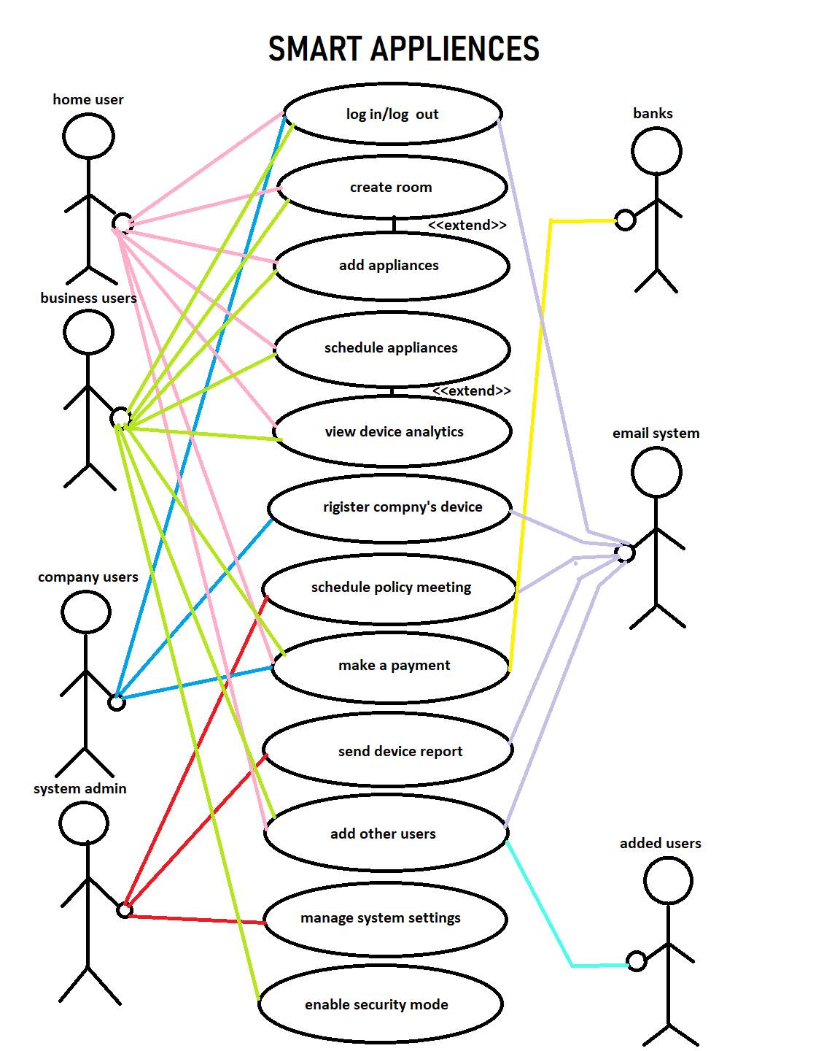

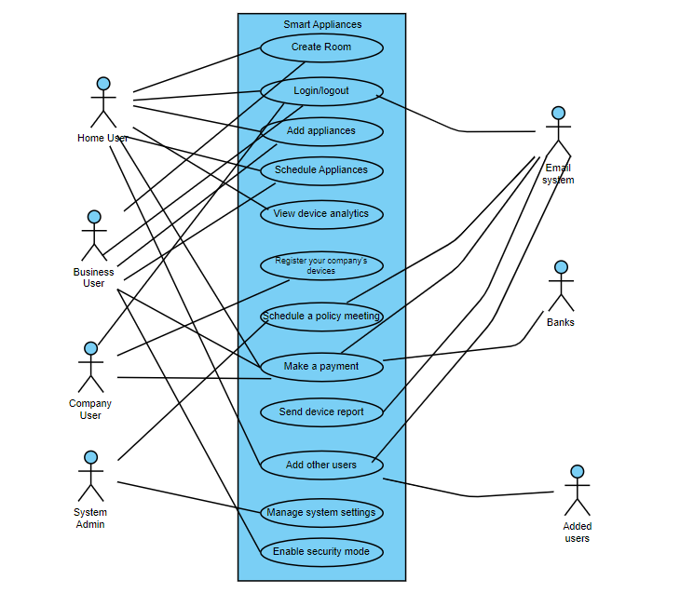

### Use Case Diagram 2:

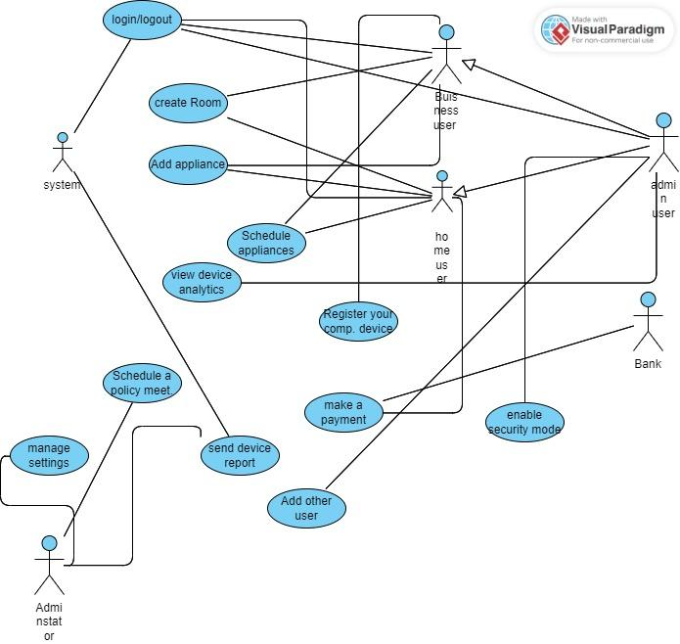

# Step 4: Requirement Specification:

In this step, we are going to write an SRS document. This document shows our work for the project related to what we are doing so we will be writing SRS on a different document. Here is the link:

<https://docs.google.com/document/d/1_qKL4fOOOroqELMM5f7TsukiECdNJp8Yf-t2RJrdr0M/edit?usp=sharing>

# Step 5: Requirement Validation:

## 5.1: Review the requirements:

Upon self analysis of the requirements, we have found no gaps that can further arise issues during the development process. This comes after reading the initial requirements, analyzing them via use cases and then writing SRS. Almost none of the requirements go against the user’s required or desired requirements. Similarly, none of the major gaps found in the stakeholder’s requirement from the system which in our case are us. Upon the thorough initial examination of the vision and scope document, the business requirements and comparing it with the system that we are expected to see, none of the major gaps have been found. Hence, we can move to the next phase.

## 5.2: Testing the requirements:

We will be doing a hypothetical testing on the following areas:  
Based on the provided information, I can create some test cases and scenarios for your system to help you validate the requirements. Here are a few examples:

### 1. Test Case: Payment Processing

- Scenario: Home user initiates a payment transaction

- Steps:

1. Enter payment details (.amount, payment method)

I am adding details such as 3,000 rupees.

2. Submit the payment request

I assume you will submit the request by clicking the OK button.

3. Verify if the payment is processed successfully

I assume that after clicking Ok in the previous step, the details will be processed by the bank successfully.

4. Check if a receipt is generated

I assume that an email will be sent on which the receipt will be there saying that I have paid 3000 rupees of fee for **Smart Appliances** and the email will mention my name, amount that I paid and the date and the bank through which the payment was processed through.

### 2. Test Case: Scheduling Appliances

- Scenario: Business user schedules an appliance

- Steps:

1. Select an appliance to schedule

I assume that I am scheduling a smart A/C. I will schedule it by going to the device, I will click on the smart A/C, then click on the schedule device. A window will open up.

2. Enter the desired scheduled time

I want to schedule my smart A/C between 7 PM and 6 AM.

3. Submit the scheduling request

I will click on Ok to submit the request.

4. Verify if the appliance is scheduled for the specified time

Upon clicking Ok, the system shows me the message that your smart A/C has been scheduled between 7 PM and 6 AM.

### 3. Test Case: Room Creation

- Scenario: Home user creates a room

- Steps:

1. Provide a room name

I write room name as “living room”

2. Submit the room creation request

I click on “Ok”.

3. Check if the room is created successfully with the specified name

Upon clicking Ok, the system shows me the message that the living room has been created.

### 4. Test Case: Adding Appliance to a Room

- Scenario: Business user adds an appliance to a room

- Steps:

1. Select a room to add the appliance

I am working in an IT office and want to add a smart light into my meeting room. I click on the meeting room and then go to the add appliance option. I clicked on that option.

2. Choose an appliance to add

I scan the QR code from the back of my smart light.

3. Submit the request to add the appliance to the selected room

I click on the Ok button.

4. Verify if the appliance is successfully added to the specified room

Upon clicking the Ok button, the system shows me a message that your smart light has been added to the meeting room.

### 5. Test Case: Email Notification

- Scenario: System sends an email notification to a specific user

- Steps:

1. Provide the recipient's email address

I assume that the recipient's email address is abc@gmail.com

2. Compose an email message

I write the message to the user:

“Dear [name],

Here is your monthly device report from *Smart Appliances*. Let us know if you have any queries or questions regarding the attached report.

Regards.

*The following is a system-generated email.*

Attachment:

Monthly report.pdf”

3. Submit the request to send the email

The system clicks the send button to send the email.

4. Check if the email is delivered to the specified user

We can view in the “sent” options to see if the email has been sent and upon the system’s inspection, the email was sent to the user.

## 5.3: Defining acceptance criteria:

### 1. Functionality:

- The system should accurately process and record user payments without errors.

[verified, status: excellent]

- Users should be able to schedule appliances successfully, and the system should reflect the scheduled times accurately.

[verified, status: excellent]

- Users should be able to create rooms and add appliances to them, with the changes reflected in the system.

[verified, status: excellent]

### 2. Performance:

- The system should respond to user actions within an acceptable time frame to ensure a smooth and responsive user experience.

[verified, status: excellent]

- Data retrieval, processing, and rendering should occur within a reasonable time frame, ensuring efficient operation of the system.

[verified, status: very good]

### 3. Security:

- The system should enforce appropriate access controls to ensure that only authorized users can access and perform specific actions within the application.

[verified, status: very good]

- User data should be handled securely, employing encryption and appropriate data protection measures to safeguard privacy.

[verified, status: good]

### 4. Usability:

- The system should be intuitive and easy to learn for users, requiring minimal training or guidance.

[verified, status: excellent]

- Error messages and feedback provided by the system should be clear and informative, assisting users in error avoidance and recovery.

[verified, status: very good]

Above is a hypothetical acceptance criterion based upon our understanding of the user.

## 5.4: Simulate the requirements:

1. Ease of Use: Interact with the simulated system and evaluate how easy it is to navigate and perform tasks. Consider the clarity of menu options, button labels, and the overall organization of the user interface. Note any areas where the system could be simplified or streamlined to enhance ease of use.

[Verified via prototyping, status: very good]

2. Clarity of Instructions: Evaluate the clarity and comprehensibility of instructions provided within the system. Assess if the steps for performing tasks, such as making a payment or scheduling appliances, are clearly communicated. Identify any areas where the instructions could be improved to avoid ambiguity or confusion.

[Verified via prototyping, status: very good]

*The instructions can be improved in the final system.*

3. Intuitiveness of Interactions: Assess the intuitiveness of the system's interactions. Evaluate if users can easily understand how to interact with the system to accomplish their goals. Consider the logical flow of actions and whether users can easily discover and access the functionalities they need. Identify any areas where the interactions could be made more intuitive or user-friendly.

[Verified via prototyping, status: very good]

*We have tried our best to make it as user-friendly as possible.*

4. Error Handling: Simulate scenarios where errors or invalid inputs occur. Evaluate how the system handles these errors and provides feedback to the user. Assess if error messages are clear and actionable, guiding users to correct their input or resolve the issue. Identify any areas where the error handling could be improved to provide better guidance and support to users.

[Verified via hypothetical understanding, status: very good]

*Since we don’t have any system in place, a hypothetical validation has been made in case of error handling.*

Throughout the user experience evaluation, take note of any areas where the system flow or design could be improved to enhance user satisfaction and usability. Consider feedback from a user's perspective and identify potential enhancements that could make the system more intuitive, efficient, and user-friendly. These observations will provide insights into the user experience and help guide future improvements when developing the actual system.

*Due to shortage of time, we can’t really take the user’s input as of now. Hence, we have gone back to study our requirement elicitation steps and conclude that we have matched almost all of the user requirements in our later steps.*

# Step 6: Prototyping:

### Home user prototype:

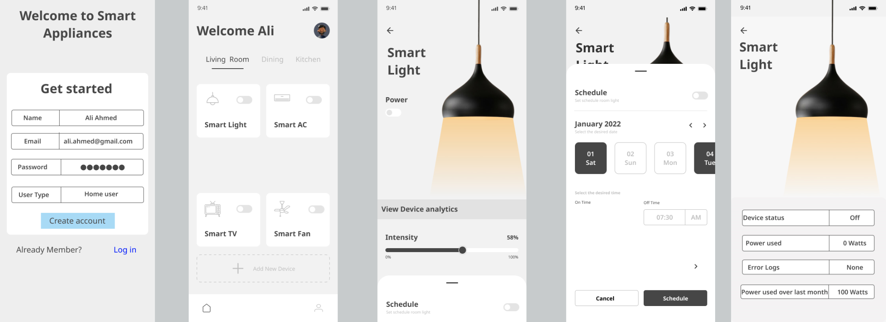

The prototype will be the same for business users with a difference that the second screen will have a security tag at its center to enable security mode.

### Company user prototype:

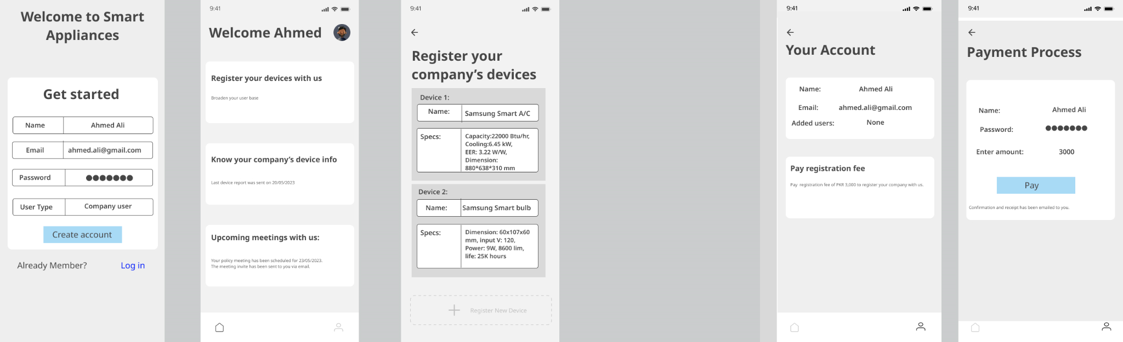

### System admin prototype:

